**EX.NO:2 DATE: 23.01.2025**

**RGB TO CMY COLOR MODEL AND RGB TO HSV COLOR MODEL**

**AND SPLITTING RGB AND HSV**

# Aim

To Understand and execute the different color models and also visualizing the respective color split planes

# Algorithm

**1. RGB to CMY Color Model**

1. **Load the Input Image:**
   * Use cv2.imread() to load the image in RGB format.
2. **Convert Color Space:**
   * Convert the image from BGR to RGB using cv2.cvtColor().
3. **Normalize Pixel Values:**
   * Scale the pixel values to the range [0, 1] by dividing each value by 255.
4. **Compute CMY Values:**
   * Apply the formulas:
     1. C=1−RC = 1 - RC=1−R, M=1−GM = 1 - GM=1−G, Y=1−BY = 1 - BY=1−B.
   * Scale the CMY values back to the range [0, 255] and convert them to integers.
5. **Save and Display:**
   * Save the resultant CMY image using cv2.imwrite() and display it.

**2. RGB Color Splitting**

1. **Import Necessary Modules:**
   * Use libraries like cv2 and matplotlib.pyplot.
2. **Load the Image:**
   * Read the RGB image with cv2.imread().
3. **Separate Color Channels:**
   * Use cv2.split() to extract the R, G, and B channels.
4. **Save Results (Optional):**
   * Save the individual grayscale channel images with cv2.imwrite().

**3. RGB to HSV Color Model**

1. **Import Libraries:**
   * Include cv2 and matplotlib.pyplot.
2. **Load the Image:**
   * Read the input image using cv2.imread().
3. **Convert RGB to HSV:**
   * Use cv2.cvtColor() with the cv2.COLOR_BGR2HSV flag.
4. **Display the Result:**
   * Visualize the HSV image.

**4. HSV Color Splitting**

1. **Import Required Libraries:**
   * Import numpy and cv2.
2. **Load the Image:**
   * Use cv2.imread() to load the image in BGR format.
3. **Convert to HSV:**
   * Convert the image to HSV color space using cv2.cvtColor() with the cv2.COLOR_BGR2HSV flag.
4. **Split HSV Channels:**
   * Extract the Hue, Saturation, and Value channels using cv2.split().
5. **Display Results:**
   * Show the separated channels.

**5. RGB to YIQ Color Model**

1. **Load the RGB Image:**
   * Use cv2.imread() to load the image.
2. **Define YIQ Conversion Matrix:**
   * Use the following transformation matrix: 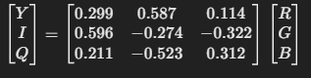
3. **Normalize Pixel Values:**
   * Scale RGB values to the range [0, 1].
4. **Perform Matrix Multiplication:**
   * Apply the transformation matrix to compute the YIQ values.
5. **Save and Display:**
   * Save the YIQ image using cv2.imwrite() and display the result.

# CODE

# COLOR MODELS

import cv2  
import matplotlib.pyplot as plt  
import numpy as np  
import seaborn as sns

image = cv2.imread("FRUITS.jpg",1)  
image1 = cv2.cvtColor(image,cv2.COLOR_BGR2RGB)  
image.shape

(1414, 2119, 3)

image = cv2.imread("image1.jpg",1)  
image2 = cv2.cvtColor(image,cv2.COLOR_BGR2RGB)  
image.shape

(2160, 3840, 3)

fig, axs = plt.subplots(1, 2)  
axs[0].imshow(image1)  
axs[0].axis('off')  
axs[1].imshow(image2)  
axs[1].axis('off')   
plt.show()

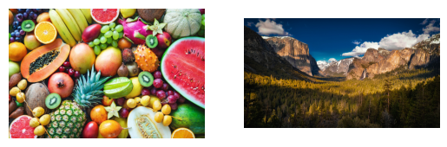

# R,G,B Image Planes

#IMAGE1  
B, G, R = cv2.split(image)  
  
zeros = np.zeros_like(B)  
  
red_image = cv2.merge([zeros, zeros, R])  
green_image = cv2.merge([zeros, G, zeros])  
blue_image = cv2.merge([B, zeros, zeros])  
  
red_image = cv2.cvtColor(red_image, cv2.COLOR_BGR2RGB)  
green_image = cv2.cvtColor(green_image, cv2.COLOR_BGR2RGB)  
blue_image = cv2.cvtColor(blue_image, cv2.COLOR_BGR2RGB)  
  
fig, axs = plt.subplots(1, 3, figsize=(15, 5))  
axs[0].imshow(red_image)  
axs[0].set_title('Red Channel')  
axs[0].axis('off')  
  
axs[1].imshow(green_image)  
axs[1].set_title('Green Channel')  
axs[1].axis('off')  
  
axs[2].imshow(blue_image)  
axs[2].set_title('Blue Channel')  
axs[2].axis('off')  
  
plt.show()  
  
cv2.imwrite('red_channel.jpg', red_image)  
cv2.imwrite('green_channel.jpg', green_image)  
cv2.imwrite('blue_channel.jpg', blue_image)

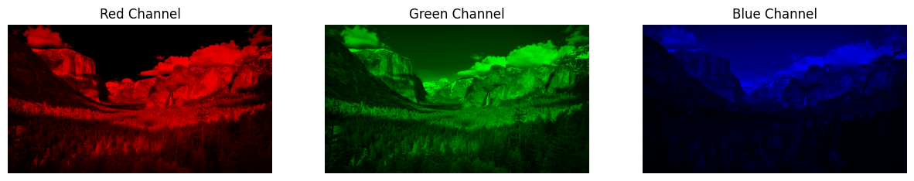

True

#IMAGE2  
B, G, R = cv2.split(image)  
  
zeros = np.zeros_like(B)  
  
red_image = cv2.merge([zeros, zeros, R])  
green_image = cv2.merge([zeros, G, zeros])  
blue_image = cv2.merge([B, zeros, zeros])  
  
red_image = cv2.cvtColor(red_image, cv2.COLOR_BGR2RGB)  
green_image = cv2.cvtColor(green_image, cv2.COLOR_BGR2RGB)  
blue_image = cv2.cvtColor(blue_image, cv2.COLOR_BGR2RGB)  
  
fig, axs = plt.subplots(1, 3, figsize=(15, 5))  
axs[0].imshow(red_image)  
axs[0].set_title('Red Channel')  
axs[0].axis('off')  
  
axs[1].imshow(green_image)  
axs[1].set_title('Green Channel')  
axs[1].axis('off')  
  
axs[2].imshow(blue_image)  
axs[2].set_title('Blue Channel')  
axs[2].axis('off')  
  
plt.show()  
  
cv2.imwrite('red_channel.jpg', red_image)  
cv2.imwrite('green_channel.jpg', green_image)  
cv2.imwrite('blue_channel.jpg', blue_image)



True

# RGB to CMY

#IMAGE1  
cmy = 255 - image1  
plt.figure(figsize=(12, 10))  
  
plt.subplot(1, 2, 1)  
plt.imshow(image1)  
plt.title('RGB IMAGE')  
plt.axis('off')  
  
plt.subplot(1, 2, 2)  
plt.imshow(cmy)  
plt.title('CMY IMAGE')  
plt.axis('off')  
  
plt.show()

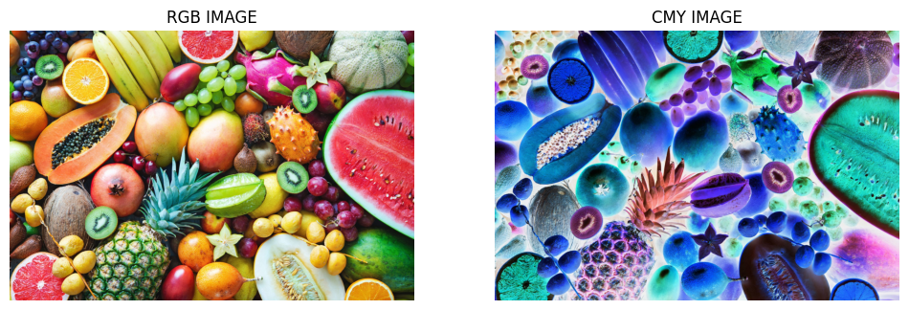

#IMAGE2  
cmy = 255 - image2  
plt.figure(figsize=(12, 10))  
  
plt.subplot(1, 2, 1)  
plt.imshow(image2)  
plt.title('RGB IMAGE')  
plt.axis('off')  
  
plt.subplot(1, 2, 2)  
plt.imshow(cmy)  
plt.title('CMY IMAGE')  
plt.axis('off')  
  
plt.show()

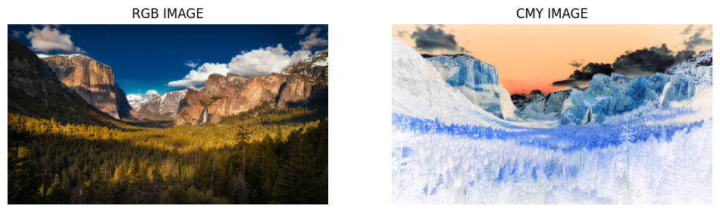

# RGB TO HSV

#IMAGE 1  
hsv_image = cv2.cvtColor(image1,cv2.COLOR_RGB2HSV)  
  
plt.imshow(hsv_image)  
plt.axis('off')  
plt.show()

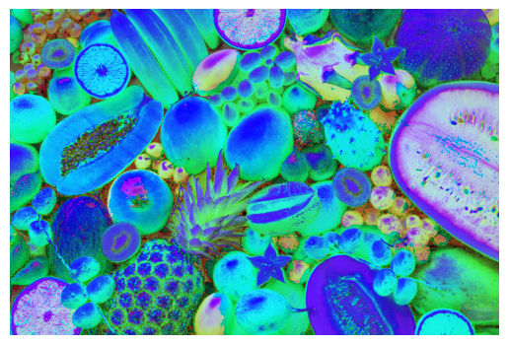

#IMAGE 2  
hsv_image2 = cv2.cvtColor(image2,cv2.COLOR_RGB2HSV)  
  
plt.imshow(hsv_image2)  
plt.axis('off')  
plt.show()

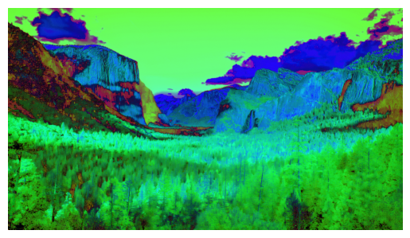

# HSV Individual Channels

#IMAGE 1  
img = cv2.imread("image1.jpg")  
img_rgb = cv2.cvtColor(img, cv2.COLOR_BGR2RGB)  
img_hsv = cv2.cvtColor(img_rgb, cv2.COLOR_RGB2HSV)  
h, s, v = cv2.split(img_hsv)  
  
h += 7  
s += 0  
  
img_adj = cv2.merge([h,s,v])  
imgf = cv2.cvtColor(img_adj, cv2.COLOR_HSV2RGB)  
plt.figure(figsize=(13,5))  
plt.subplot(2, 3, 1)  
plt.imshow(h)  
plt.title("Hue Channel")  
plt.axis('off')  
plt.subplot(2, 3, 2)  
plt.imshow(s)  
plt.title("Saturation Channel")  
plt.axis('off')  
plt.subplot(2, 3, 3)  
plt.imshow(v)  
plt.title("Value Channel")  
plt.axis('off')  
plt.subplot(2, 3, 4)  
plt.imshow(img_rgb)  
plt.title("RGB image")  
plt.axis('off')  
plt.subplot(2, 3, 5)  
plt.imshow(img_hsv)  
plt.title("HSV image")  
plt.axis('off')  
plt.subplot(2, 3, 6)  
plt.imshow(imgf)  
plt.title("Final image")  
plt.axis('off')  
plt.show()

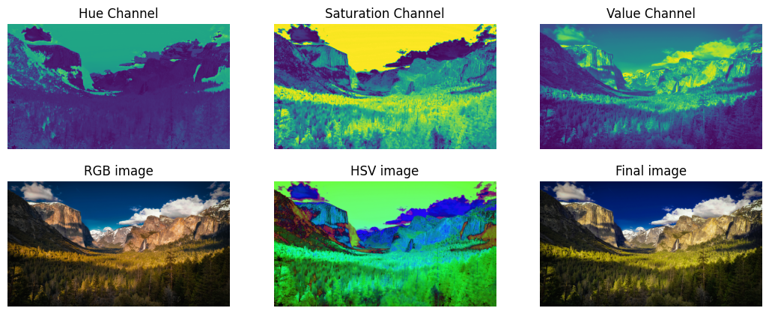

#IMAGE 2  
img = cv2.imread("FRUITS.jpg")  
img_rgb = cv2.cvtColor(img, cv2.COLOR_BGR2RGB)  
img_hsv = cv2.cvtColor(img_rgb, cv2.COLOR_RGB2HSV)  
h, s, v = cv2.split(img_hsv)  
  
h += 7  
s += 0  
  
img_adj = cv2.merge([h,s,v])  
imgf = cv2.cvtColor(img_adj, cv2.COLOR_HSV2RGB)  
plt.figure(figsize=(13,5))  
plt.subplot(2, 3, 1)  
plt.imshow(h)  
plt.title("Hue Channel")  
plt.axis('off')  
plt.subplot(2, 3, 2)  
plt.imshow(s)  
plt.title("Saturation Channel")  
plt.axis('off')  
plt.subplot(2, 3, 3)  
plt.imshow(v)  
plt.title("Value Channel")  
plt.axis('off')  
plt.subplot(2, 3, 4)  
plt.imshow(img_rgb)  
plt.title("RGB image")  
plt.axis('off')  
plt.subplot(2, 3, 5)  
plt.imshow(img_hsv)  
plt.title("HSV image")  
plt.axis('off')  
plt.subplot(2, 3, 6)  
plt.imshow(imgf)  
plt.title("Final image")  
plt.axis('off')  
plt.show()

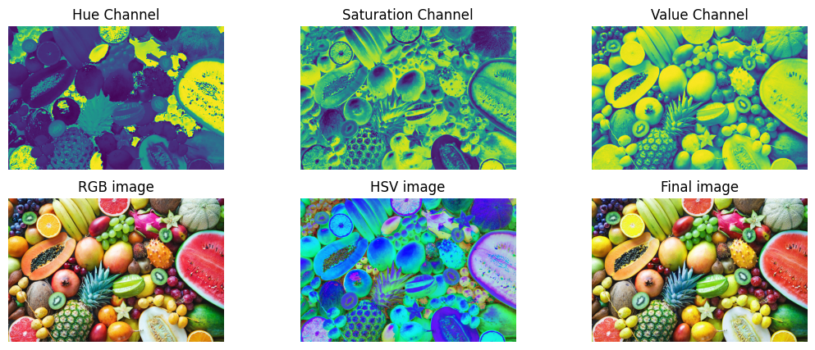

# RGB TO YIQ

#IMAGE 1  
image_rgb = image1 / 255.0  
   
transformation_matrix = np.array([  
 [0.299, 0.587, 0.114],  
 [0.5957, -0.2746, -0.3213],  
 [0.2115, -0.5227, 0.3113]])  
   
reshaped_image = image_rgb.reshape(-1, 3)   
yiq_image = reshaped_image.dot(transformation_matrix.T)  
yiq_image = yiq_image.reshape(image_rgb.shape)  
yiq_image = np.clip(yiq_image * 255, 0, 255).astype(np.uint8)  
  
plt.figure(figsize=(12,10))  
  
plt.subplot(1, 2, 1)  
plt.imshow(image_rgb)  
plt.title("Original RGB Image")  
plt.axis('off')  
  
plt.subplot(1, 2, 2)  
plt.imshow(yiq_image)  
plt.title("Converted YIQ Image")  
plt.axis('off')  
  
plt.show()  
  
Y = yiq_image[:, :, 0]   
I = yiq_image[:, :, 1]   
Q = yiq_image[:, :, 2]   
   
I = np.clip(I + 128, 0, 255)   
Q = np.clip(Q + 128, 0, 255)   
  
plt.figure(figsize=(13,7))  
  
plt.subplot(2, 3, 1)  
plt.imshow(Y)  
plt.title("Y Channel")  
plt.axis('off')  
   
plt.subplot(2, 3, 2)  
plt.imshow(I)  
plt.title("I Channel")  
plt.axis('off')  
   
plt.subplot(2, 3, 3)  
plt.imshow(Q)  
plt.title("Q Channel")  
plt.axis('off')  
   
plt.show()

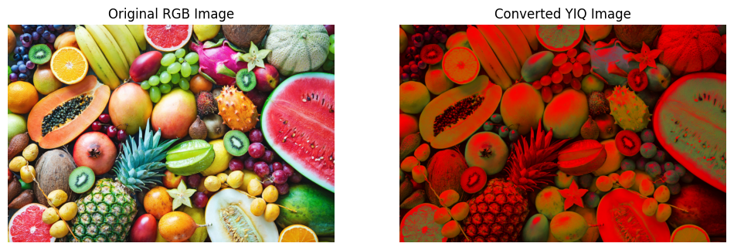

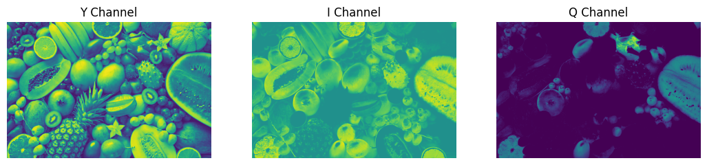

#IMAGE 2  
image_rgb = image2 / 255.0  
   
transformation_matrix = np.array([  
 [0.299, 0.587, 0.114],  
 [0.5957, -0.2746, -0.3213],  
 [0.2115, -0.5227, 0.3113]])  
   
reshaped_image = image_rgb.reshape(-1, 3)   
yiq_image = reshaped_image.dot(transformation_matrix.T)  
yiq_image = yiq_image.reshape(image_rgb.shape)  
yiq_image = np.clip(yiq_image * 255, 0, 255).astype(np.uint8)  
  
plt.figure(figsize=(12,10))  
  
plt.subplot(1, 2, 1)  
plt.imshow(image_rgb)  
plt.title("Original RGB Image")  
plt.axis('off')  
  
plt.subplot(1, 2, 2)  
plt.imshow(yiq_image)  
plt.title("Converted YIQ Image")  
plt.axis('off')  
  
plt.show()  
  
Y = yiq_image[:, :, 0]   
I = yiq_image[:, :, 1]   
Q = yiq_image[:, :, 2]   
   
I = np.clip(I + 128, 0, 255)   
Q = np.clip(Q + 128, 0, 255)   
  
plt.figure(figsize=(13,7))  
  
plt.subplot(2, 3, 1)  
plt.imshow(Y)  
plt.title("Y Channel")  
plt.axis('off')  
   
plt.subplot(2, 3, 2)  
plt.imshow(I)  
plt.title("I Channel")  
plt.axis('off')  
   
plt.subplot(2, 3, 3)  
plt.imshow(Q)  
plt.title("Q Channel")  
plt.axis('off')  
   
plt.show()

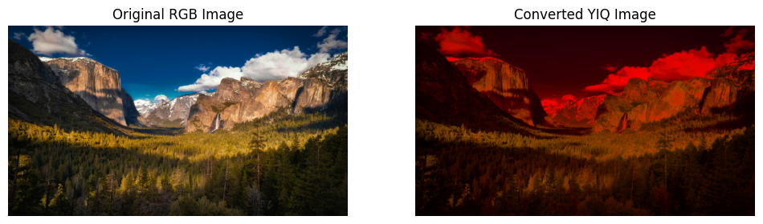

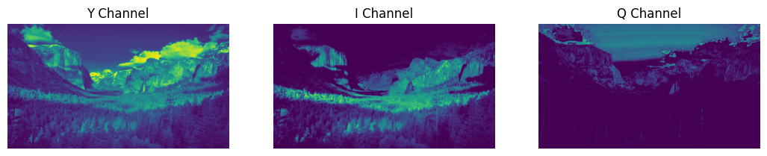

# INFERENCE

Had understood the concepts of color model and the effect on their change and splitting with the help of library open-cv

# RESULT

Thus, the concepts of change of color model and splitting executed successfully for sample images.